Final Report: BIG-ACE

|  |  |
| --- | --- |
| Client: | **Error! Unknown document property name.**/University of Twente |
|  |  |
| Project Title: | EO AFRICA R&D progress report: Deliverable D2 |
| Proposal Reference: | EOAfrica-UCL-UoW-01 |
| Submission Date: | 08/02/2022 |
| Issue: | 1 |
|  |  |
| Authors: | **Professor Philip Lewis**  **Associate Professor Elhadi Adam**  **Mr Feng Yin** |
|  |  |

Amendment Record

|  |  |  |  |
| --- | --- | --- | --- |
| Issue  2.0 | Revision  0.1 | Date  28/3/2023 | Details  Final Report Submission |

Table of Contents

Final Report: BIG-ACE 1

Applicable Documents 4

2.0 Introduction 5

3.0 Report of work done 7

3.1 Fieldwork location and farmers' meeting 7

3.2 Data Collection strategies 9

3.3 Satellite data 10

3.3 Satellite data 11

3.4 UCL ARC algorithm 17

3.5 European PI visit to South Africa 18

3.6 EO Acquisition and pre-processing 18

3.5 Modelling crop parameters using archetypes 18

3.6 Writing 18

4. Results 18

4.1 Leaf Area Index 18

4.2 Chlorophyll Concentration (Cab) 23

4.3 Results in context 26

5. Other matters 27

5.1 Finance 27

5.2 Training and workshops 27

5.3 Financial expenditure 27

6. Conclusions 27

Appendix I. Sampling protocol for LAI and Cab 28

# Applicable Documents

|  |  |  |
| --- | --- | --- |
| Document | Date | Comments |
| BIG data Archetypes for Crops from EO | 16th November 2022 | Project Proposal In response to 2022-23 call by ESA EO AFRICA R&D Facility in collaboration with AUC |
| Collaboration Agreement: Document: 7258820 - EO AFRICA COLLABORATION AGREEMENT UT AFRICAN EUROPEAN- UoT-UCL-UoW-FEA, | 20th February 2023 | University of the Witwatersrand, Johannesburg; University College London; Universiteit of Twente |
| Progress Report: BIG-ACE | 4th October 2023 | Progress report, file: EO AFRICA Progress Report Sept2023 UCL-Wits.docx |
| F. Yin, P. Lewis, J. Gomez-Dans and T Weiß , (2024 in review) “Archetypal Crop Trait Dynamics for Enhanced Retrieval of Biophysical Parameters from Sentinel-2 MSI”, Remote Sensing of Environment (awaiting review since Oct 2023) | November 2023 | Core paper on Archetype method, submitted to special Issue of RDSE but still awaiting review. |
| P. Lewis, E. Adam, J. Gomez-Dans, F. Yin, T Weiß (2024 in prep) “Validation of Archetype approach for Retrieval of Biophysical Parameters from Sentinel-2 MSI and Planet data.” | March 2024 | Draft of conference paper being prepared for ISPRS, Belem, 2024, <https://selperbrasil.org.br/events/belem-2024-tc3-symposium/> |
| F. Yin, P. Lewis, (2024) “ARchetypes for Crops from EO”, Github code and data repository | March 2023 | [https://github.com/MarcYin/ARC.](https://github.com/MarcYin/ARC) |
| F. Yin, P. Lewis, E. Adam, (2024) “BIG data Archetypes for Crops from EO”, Github code and data repository | March 2024 | <https://github.com/MarcYin/EO-AFRICA> |

# 2.0 Introduction

Global food security is of vital and increasing importance to our world and is a direct component of several UN SDGs. Monitoring crop information from Earth Observation (EO) plays a key role in supporting formation for this, for example, yield predictions and early warning systems. But current efforts such as NASA Harvest or GEOGLAM cropwatch[1] are mainly limited to resolution anomaly detection and broad crop status indicators to get the temporal sampling needed for crops. The project “BIG data Archetypes for Crops from EO” funded through the ESA/AU EO Africa R&D Facility is a joint undertaking by researchers at University College London (UCL), UK and the University of The Witwatersrand, South Africa.

The main aim of the project was to improve the information available for such monitoring by directly targeting the ‘full set’ of crop biophysical parameters for this task, moving away from the previous empirical basis to inherent crop characteristics that are physically measurable and more fully exploit the full spectral signal available in modern EO systems. The UCL team had developed this approach using a ‘big data’ analysis of EO data over US croplands, and tested the portability of the approach by validation against a suite of temporal biophysical ground measurements in Germany. A paper was in production for that work and submitted in October 2023 (Feng et al., 2024 in review RSE). In this project, we test the application of the approach to an African environment by collecting a new field dataset in South Africa, to be combined with one collected under other funding the previous year. These data then used to further test the approach and provide practical codes and data that other can use in further studies.

The approach is novel, in providing an (empirical) model of the temporal development of each of crop biophysical parameters, in coordination, the parameters of which summarise the total information on crop development available from a time series of optical EO data. We call the basis functions for the parameter development ‘archetypes’ as they express the typical development of the parameters in temporal coordination. Such a model allows this full set of biophysical crop parameters to be linked to EO measurements of bidirectional reflectance factor (BRF) via physically-based radiative transfer models. This, in turn allows for approaches to estimate the archetype model parameters from a series of EO data. Note that the EO data can, in theory, come from a set of heterogeneous sensors, although in this study we will limit ourselves to Copernicus Sentinel-2 data and Planet data separately.

Code for the project, along with the test datasets from the South African fields measurements has been placed in an open access GitHub repository[2], with an example notebook to instruct users in the approach and allow them to conduct other experiments. This will be detailed below.

This report is the ‘final report’ D2, due at KO+12 months, with reference to the “Public open-source research code repository” D3. A copy of the draft ‘open-access peer-reviewed scientific publication’ (D4) will be submitted as a separate document The project task list from the project proposal is included for reference in Figure 1, with the planned publications in Figure 2 and deliverables in Figure 3.

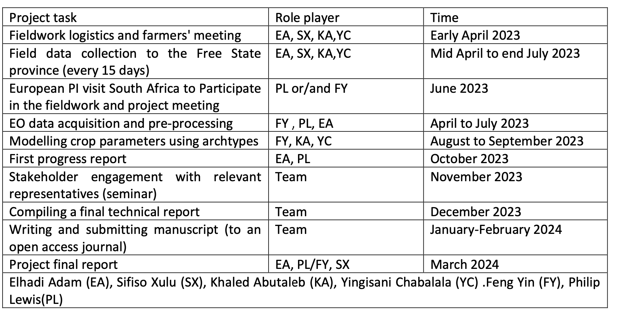

Figure 1. Project task list

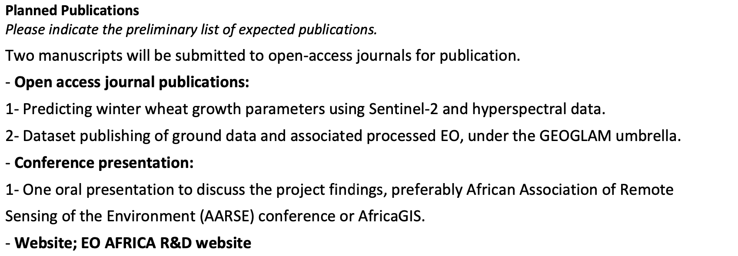

Figure 2. Planned publication list, from proposal

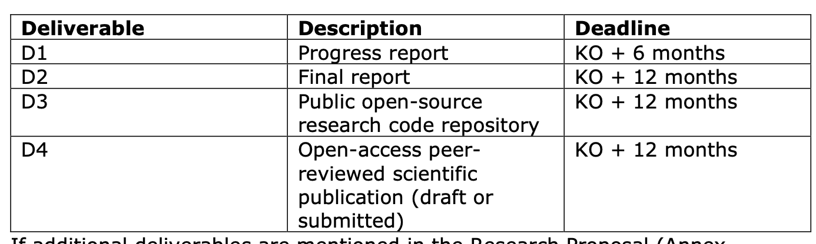

Figure 3. List of deliverables

# 3.0 Report of work done

## 3.1 Fieldwork location and farmers' meeting

The first project task was completed as planned. The data collection for this project for 2023 took take place at Syngenta's Marné Research Farm, situated on Kaallaagte Road in Meets, Bethlehem, South Africa. This location is approximately 290 kilometres away from Wits University in Johannesburg. The primary focus of the study is rainfed wheat cultivation, with the planting season commencing on September 1st. The location of the field for the 2023 data is given in the file <https://github.com/MarcYin/EO-AFRICA/blob/main/files/SF_2023.geojson>, illustrated in Figure 4.

|  |  |
| --- | --- |
|  |  |
| [A map with a road and a road sign  Description automatically generated with medium confidence](https://github.com/MarcYin/EO-AFRICA/blob/main/files/SF_2023.geojson) |  |
|  |  |

Figure 4. Various levels of zoom into the 2023 field plot <https://github.com/MarcYin/EO-AFRICA/blob/main/files/SF_2023.geojson>

The field for the 2022 measurements is slightly further North, in the Dipaleseng Local Municipality, near the town of Villiers (Figure 5), and was a circular irrigated wheat field, planted around the start of September 2022. Figure 6 shows the general area of the field sites for the two years. in 2022, measurements were taken weekly, whereas in 2023, they were recorded every 15 days. This change in the measurement interval was due to a modification in funding arrangements with UCL. The harvesting period for the crops spanned from the end of November to early December. The Leaf Area Index (LAI) and leaf chlorophyll content were the primary biophysical parameters measured.

|  |  |
| --- | --- |
|  |  |
|  |  |
|  |  |

Figure 5 Various levels of zoom into the 2022 field plot https://github.com/MarcYin/EO-AFRICA/blob/main/files/SF_2023.geojson

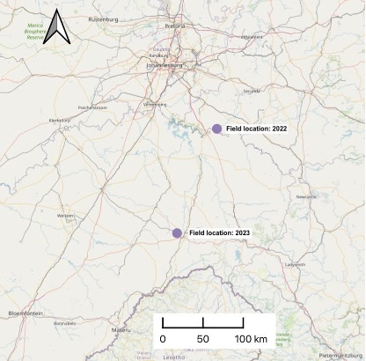

Figure 6. General area of field sites for 2022 and 2023

## 3.2 Data Collection strategies

In each field, the researchers designated five plots for measurements, each spanning an area of 50x50 meters. Within these plots, five subplots, each covering an area of 10x10 meters, were identified to collect representative data for the larger plot. To ensure accurate representation of conditions within each subplot, five separate measurements were taken and subsequently averaged. This approach provided a detailed and representative dataset of the conditions within each plot. An illustration of this sampling design is provided in Figure 7 to show the structured approach to data collection. This systematic method ensures a comprehensive and accurate representation of the biophysical parameters for the field. Details of the protocols used are given in Appendix I. Sampling protocol for LAI and Cab. 3.2 Field data collection and processing

Nine site visits were completed for 2023 and eleven for 2022. During the first visit each year, we placed and marked the plot samples. The actual plot locations are shown in Figure 11. We also recorded GPS coordinates for the central points of the subplots and collected soil spectral measurements from these subplots to support data interpretation. During subsequent visits, we measured the biophysical and biochemical parameters of the crops in accordance with the research proposal. Fieldwork continued at 15-day intervals for 2023 and weekly for 2022.

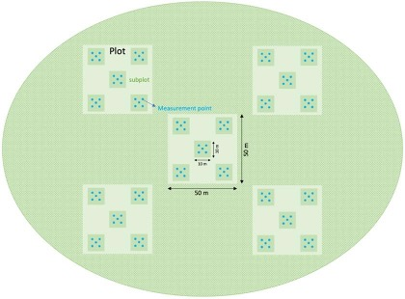

Figure 7. Illustration of field sampling design.

|  |  |  |
| --- | --- | --- |
|  | 2022 | 2023 |
| LAI |  |  |
| Cab |  |  |

Figure 8. Sample locations in fields for both years, shown over maximum value oif the biophysical parameter inferred from Sentinel-2 MSI.

## 3.3 Satellite data

The results of the field data collection are shown in Figure 9. Crop field measurements for 2022 and 2023 seasons (mean) The nine sampling times for 2023 and 11 for 2022 are shown in the graphs. The data clearly spans the dynamics of the crop. Notice that the maximum LAI is only around 2.3 for 2023 (the rainfed-crop) but 6 for the irrigated crop in 2022. The magnitude of chlorophyll concentration is similar in the two years, although the curve is smoother in 2022 than 2023. For LAI, the 2023 average curve is somewhat smoother than that for 2022.

|  |  |  |
| --- | --- | --- |
|  | 2022 | 2023 |
| LAI |  |  |
| Cab |  |  |

Figure 9. Crop field measurements for 2022 and 2023 seasons (mean)

## 3.3 Satellite data

The study mainly uses surface reflectance data from the Sentinel-2 satellite, specifically the Level 2A product, accessible via Google Earth Engine for the years 2022 and 2023. This data covers the fields where measurements were conducted and is used in estimating biophysical parameters. The Sentinel Hub's s2cloudless algorithm is applied to eliminate pixels affected by clouds.

Given the absence of official uncertainty metrics within the Sentinel-2 surface reflectance product, a nominal uncertainty of 10% is adopted for the analysis. This assumed uncertainty is incorporated into the process of retrieving biophysical parameters, serving as a conservative estimate to account for potential variations in satellite data accuracy and the official atmospheric correction method.

The time series of available Sentinel-2 MSI images is shown in Figure 11 and Figure 12 for 2023 and 2022 respectively. Data span form day of year (DOY) 216 (4th August) to DOY 341 (7th December). There are 24 images available for 2023 and 26 for 2022, although cloud cover over the site of interest reduces this to around 16 and 19 respectively.

Further data from Planet were used to investigate the impact of having more samples, but fewer wavebands. We can see that there are 87 clear images for 2023 and 97 for 2022. The Planet PS2.SD data has been calibrated to S2 MSI reflectance, which makes it straightforward to use the ARC code (calibrated for S2). The bands for the Planet data are:

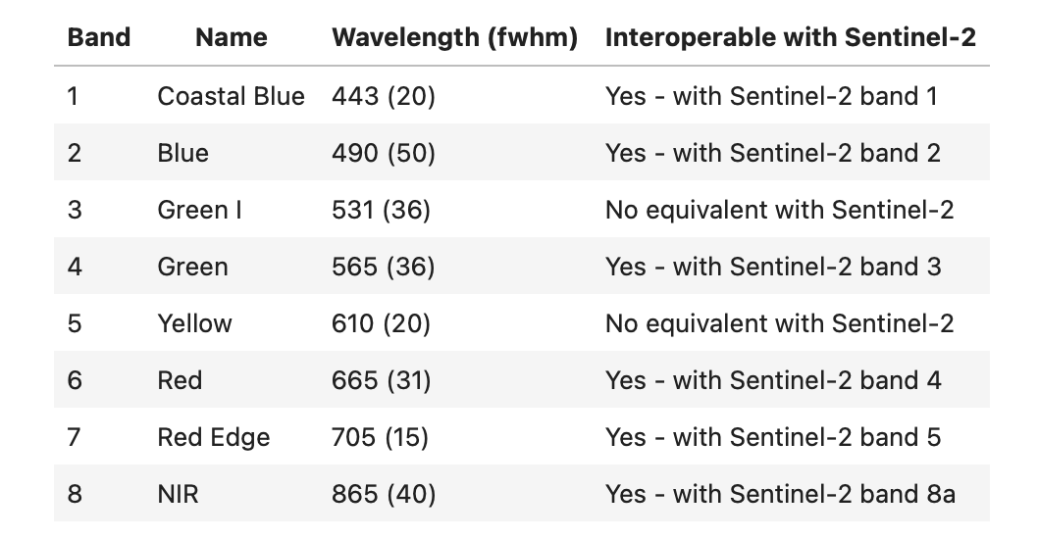

Figure 10. Planet wavebands, showing Sentinel-2 MSI equivalents

So, we can directly swap the S2 band 2, 3, 4, 5，8a with the Planet bands 2, 4, 6, 7, 8 and assume a uncertainty of 10% for the Planet data.

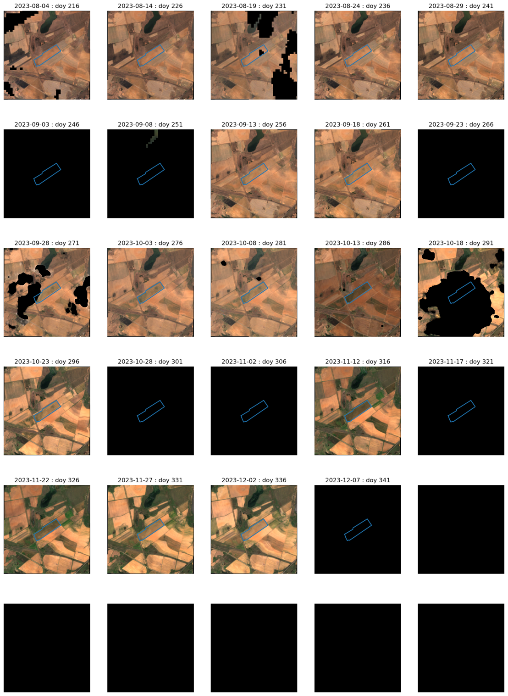

Figure 11. RGB images of Sentinel-2 data over the field site (field marked in blue) for 2023

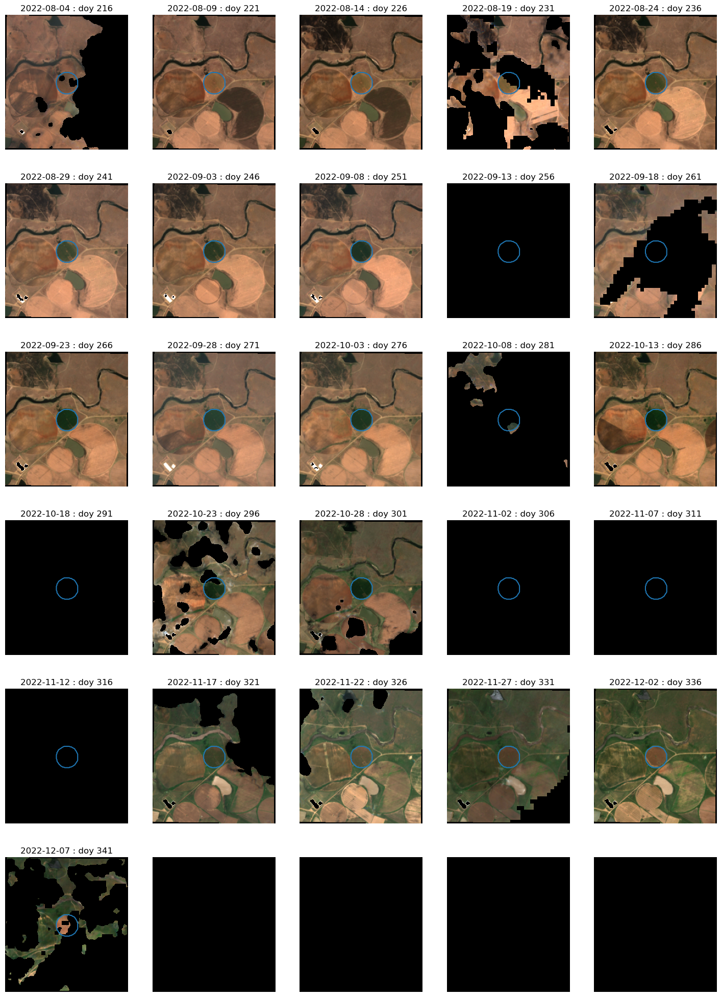

Figure 12. RGB images of Sentinel-2 data over the field site (field marked in blue) for 2022\

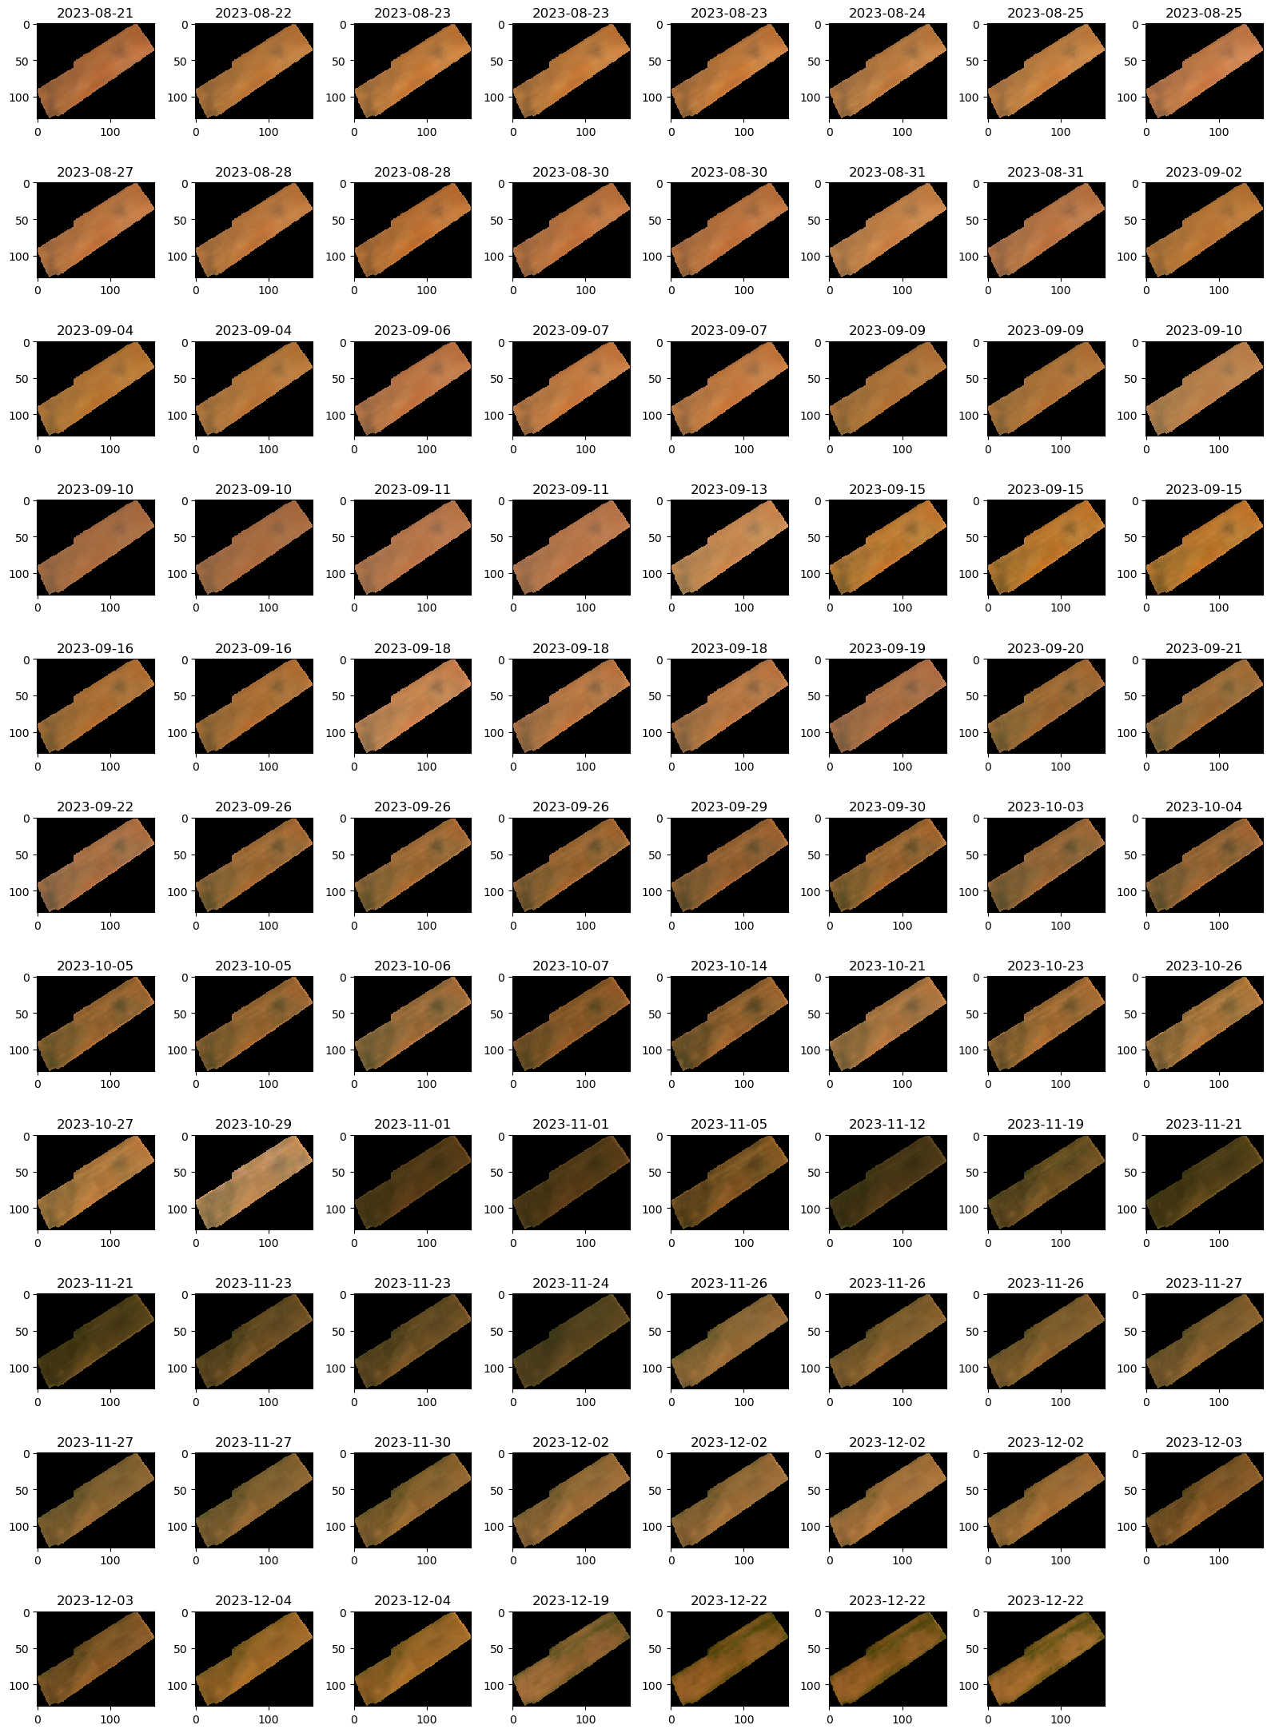

Figure 13. RGB images of Planet data over the field site for 2023

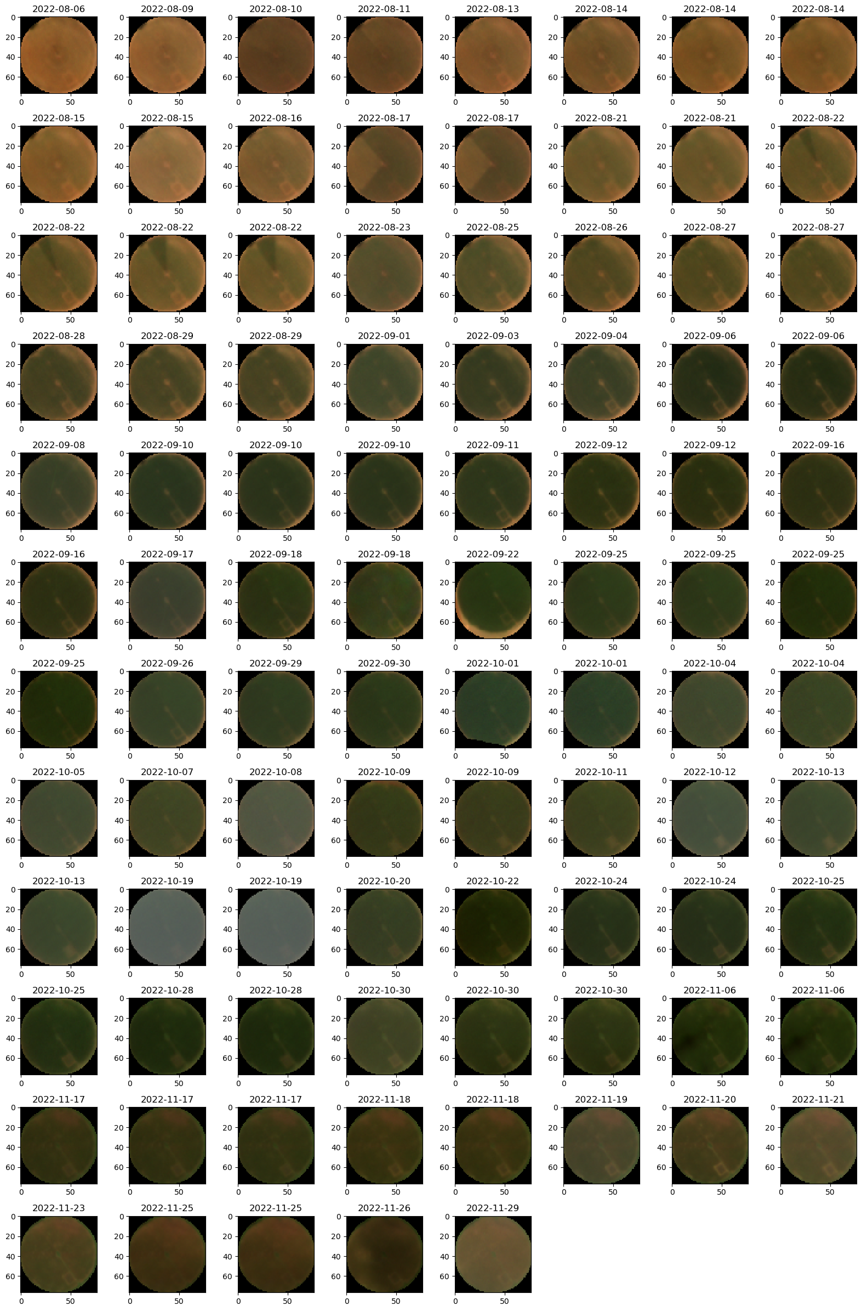

Figure 14. RGB images of Planet data over the field site for 2022

## 3.4 UCL ARC algorithm

The UCL team has developed a dynamic model for simulating biophysical parameters, such as Leaf Area Index (LAI) and leaf chlorophyll content, as well as surface reflectance time series, building on their previous work (Yin et al., 2024). This model is used in the ARC algorithm, where a Monte Carlo solver is proposed to solve time series of PROSAIL biophysical parameters from time series of satellite observations. A corresponding Python package has been made available on GitHub: [https://github.com/MarcYin/ARC.](https://github.com/MarcYin/ARC) Using this package, we can retrieve time series data of LAI and chlorophyll content from Sentinel-2 surface reflectance imagery. The package was installed on a JupyterLab instance hosted by the EO AFRICA R&D Facility Innovation Lab, leveraging the facility's computational resources for the retrieval of biophysical parameters from Sentinel-2 data. It is also directly available with the full EO-AFRICA datasets by running the notebooks in <https://github.com/MarcYin/EO-AFRICA> on a local installation. One feature of the current version of ARC is that it assumes that the soil reflectance is constant throughout the season. This generally does not cause significant problems, as the sensitivity to soil reflectance variations (e.g. caused from water dynamics) decreases with increasing LAI, and will generally be very low once there is full crop cover.

|  |  |  |
| --- | --- | --- |
|  | 2022 | 2023 |
| LAI |  |  |
| Cab |  |  |

Figure 15. Crop field measurements for 2022 and 2023 seasons (mean)

## 3.5 European PI visit to South Africa

The proposed visit of the European PI to the field site was delayed due to the later than expected crop season start, complicated by issues relating to the UCL PI taking early retirement during the timeframe of this project, and finally not possible. Instead, we have kept in touch with on-line meetings, and were able to fund a visit for the African PI to the UK for detailed project planning from other sources.

## 3.6 EO Acquisition and pre-processing

Acquisition and processing of EO data has been completed for both years and used for archetype validation. A version of these data are made available to users via GoogleEarth Engine in the project notebook.

## 3.5 Modelling crop parameters using archetypes

As noted above, field dataset for 2022 and 2023 has been processed. Data are available to users via the project notebook.

## 3.6 Writing

The UCL team submitted a paper to a special issue of Remote Sensing of Environment on the Archetype approach in November 2023. That paper is still undergoing peer review, but scientifically, since it describes the method, we need that paper to be published (or at least accepted) before we can submit validation/application papers using the South African data. The November 2023 paper contains a small amount of parameters validation, over a test site in Germany. We are continuing work on the main paper coming from this work, a fuller validation study using the 2022 dataset using the new data which we will submit as Deliverable D4. All datasets we collect here and previous ones we have directly collected will be made available via a zenodo site. They are also directly available via the GitHub site that contains the project notebooks. In the interim, we are preparing a conference paper, authored by all project collaborators, for the ISPRS conference in Belem, November 2024 <https://selperbrasil.org.br/events/belem-2024-tc3-symposium/>. The paper is still in development but will be submitted soon after Easter. It describes the archetype method, and shows the validation. Data for the German site, as well as the South African sites.

# 4. Results

Experimental results are shown in detail in the various Jupyter notebooks. We show the bottom-line results here, and provide some explanation.

## 4.1 Leaf Area Index

The ability to robustly estimate LAI is key to this application. The results of comparisons against the ground data for experiments with Sentinel-2 MSI ([2022](https://github.com/MarcYin/EO-AFRICA/blob/main/ARC_Validation_SA_2022_BIGACE.ipynb)) ([2023](https://github.com/MarcYin/EO-AFRICA/blob/main/ARC_Validation_SA_2023_BIGACE.ipynb)) are shown, along with equivalent results when ARC is driven the denser Planet timer series ([2022](https://github.com/MarcYin/EO-AFRICA/blob/main/arc_2022_planet.ipynb)) ([2023](https://github.com/MarcYin/EO-AFRICA/blob/main/arc_2023_planet.ipynb)).

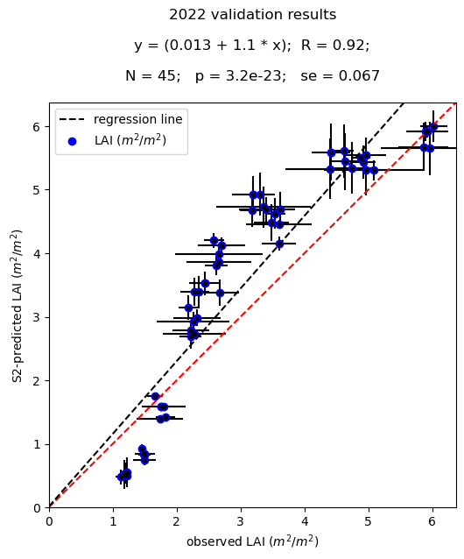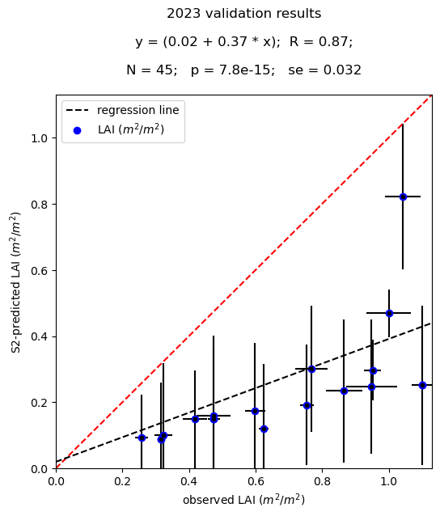

Figure 16. LAI validation using Sentinel-2 MSI for 2022 and 2023 seasons

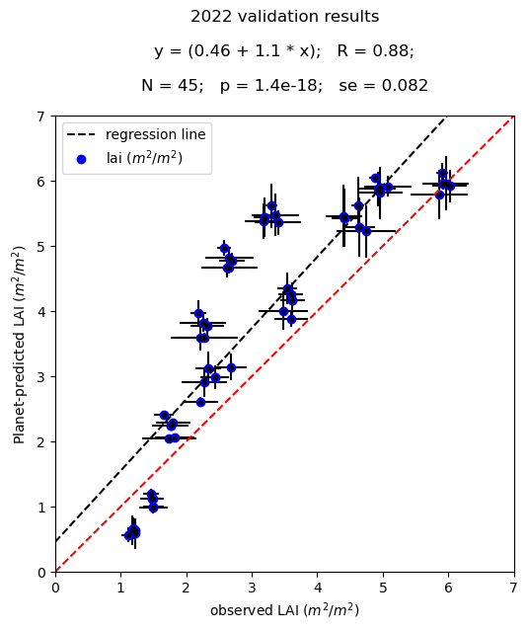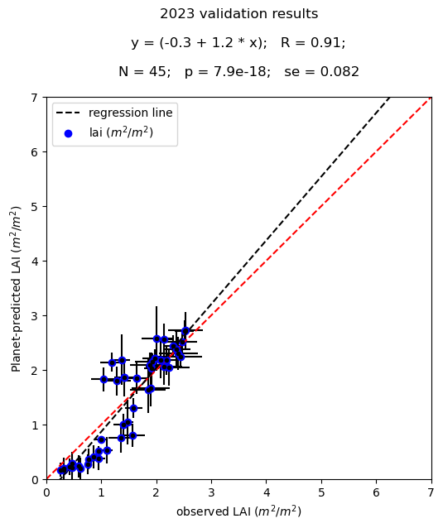

Figure 17. LAI validation using Planet for 2022 and 2023 seasons

Both datasets perform very well for LAI for the 2022 dataset, with its higher dynamic range of LAI, and the results using Planet or MSI are remarkably similar. Recall that for Planet, we use only 4 wavebands, but with much higher sampling density, but for MSI we have more wavebands but many fewer samples. The result is shown in more detail in Figure 18, with time series of measured and estimated LAI shown for each of the five sub-plots. The satellite data samples are shown as black dots, and we can see the much higher density of plots in the Planet result compared to the MSI result. But since both datasets span the dynamics of the signal well, the results are very similar. This is a very encouraging, and suggests that we might in the future perform estimates with heterogeneous systems (e.g. a mixture of Planet and MSI and Landsat data).

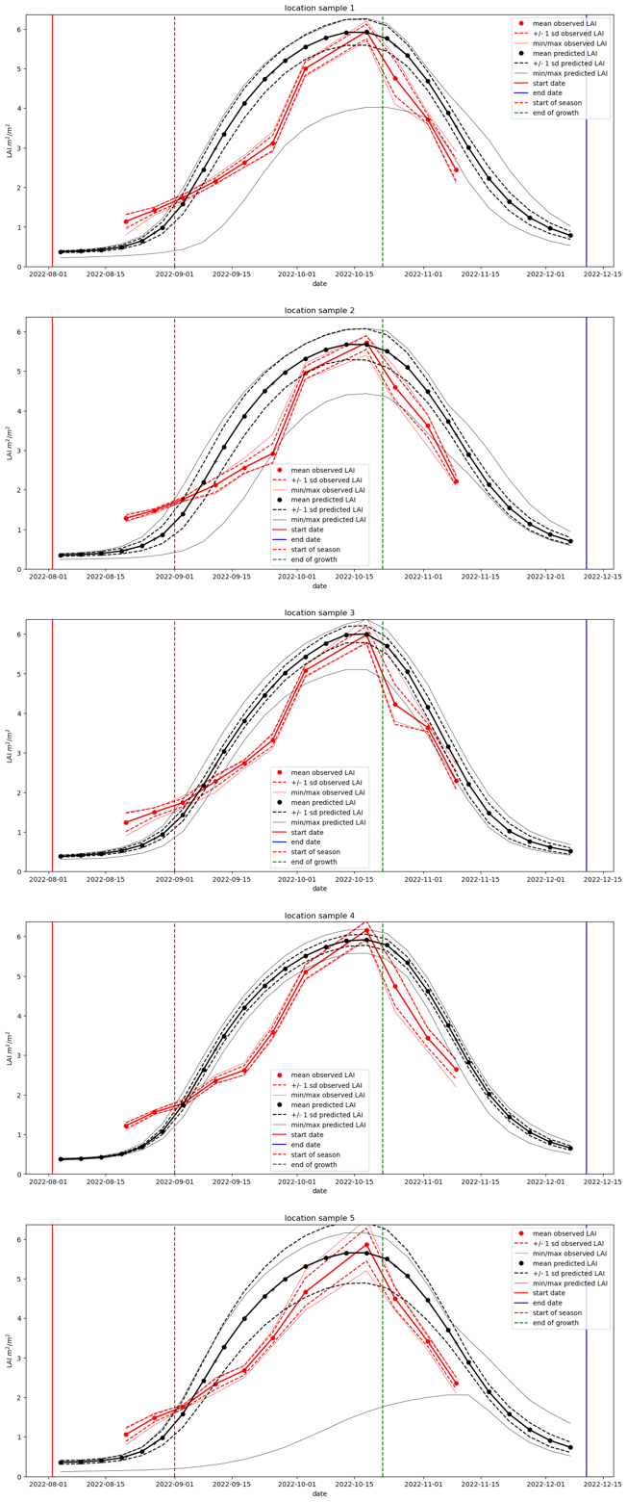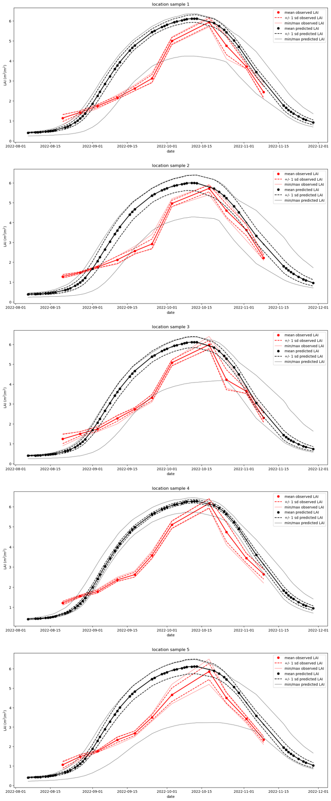

Figure 18. Time series of measured (red) and estimated (black) LAI from Sentinel-2 MSI (left) and Planet (right) for 2022

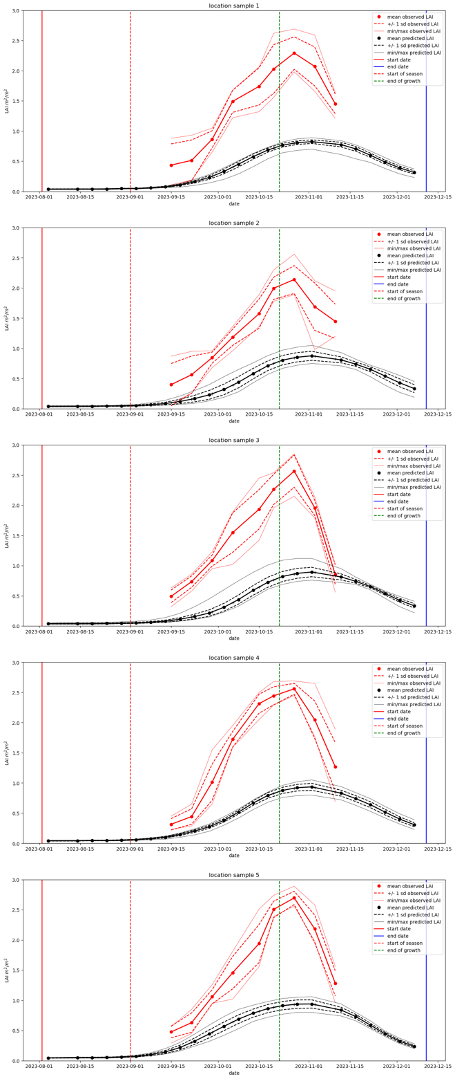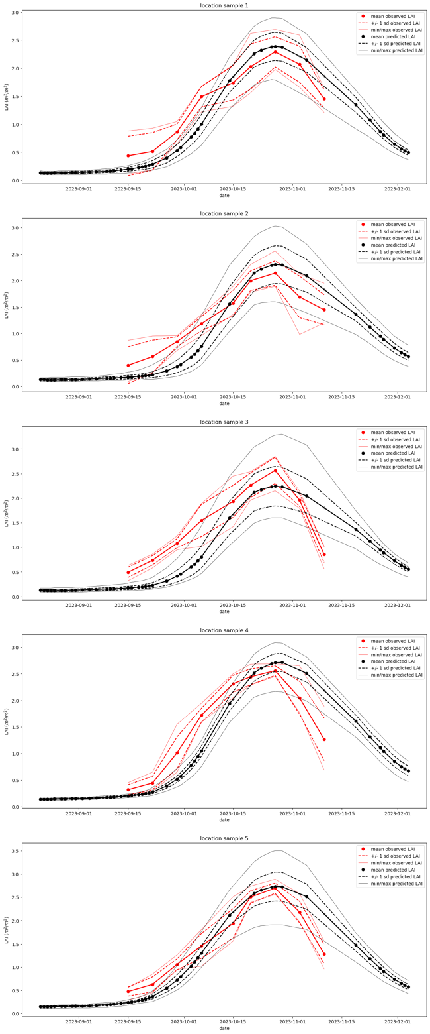

Figure 19. Time series of measured (red) and estimated (black) LAI from Sentinel-2 MSI (left) and Planet (right) for 2023

For 2023 however (Figure 19), the performance seems significantly poorer for the MSI data than for Planet. A quick look at the sampling suggests this is reasonable for MSI over the whole time period, but still, critical samples needed to constrain the magnitude of LAI peak behaviour may be missing. So, the lower information content but better temporal sampling of the Planet data might produce a much better result. Figure 20 shows the temporal sampling for 2023 more clearly, visualised as NDVI however, and we see that this may be the case, with denser sampling from Planet data in the green-up period. But in fact, the story behind this crop is much more complex, and the seemingly poor performance for MSI is likely a consequence of that.

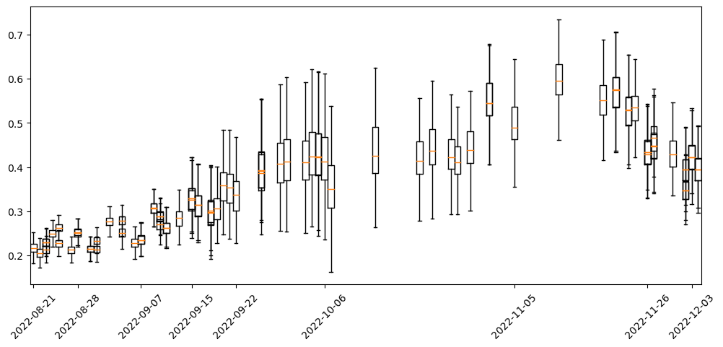

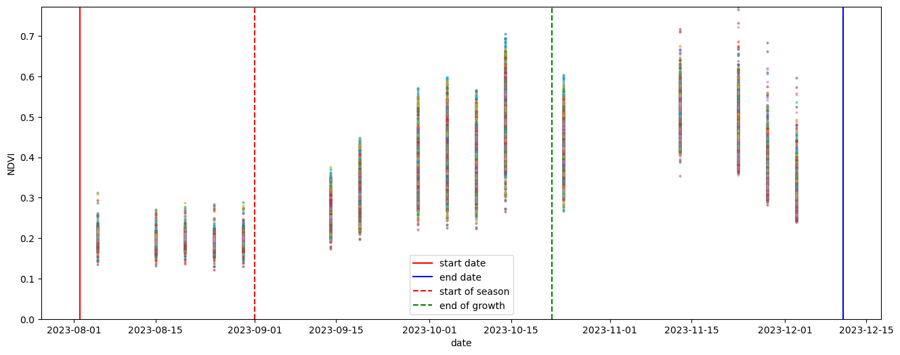

Figure 20. Time series NDVI from Sentinel-2 MSI (lower) and Planet (upper) for 2023 over the whole test field

The field used in 2023 is rain-fed, and so more sensitive to water availability. It suffered from a significant drought in the green-up period, as shown in the soil moisture dataset in Figure 21, which is probably a significant factor affecting the final LAI of the crop. Since the resulting LAI is quite low, the crop reflectance maintains a sensitivity to soil moisture throughout the season. We can see this in the near infrared (NIR) measurements from Planet in Figure 21. For the Planet analysis then, we remove samples after green-up when the soil moisture is low to minimise the influence of these. On doy 250 (October 7th), there is an anormal decrease in the red edge band but not in the red band, it is likely due to sensor calibration issues (see graph in [Notebook](https://github.com/MarcYin/EO-AFRICA/blob/main/arc_2023_planet.ipynb)). We remove this day from the analysis. So, whilst Planet data provide a lot more samples that MSI, they do have some issues that mean they need careful filtering. The analysis with Planet data also shows that for a canopy with relatively low LAI (typical of rain-fed crops in many parts of Africa (Gomez-Dans et al., 2022[3])). It may be that the MSI result would benefit from additional filtering, but that has not been attempted here.

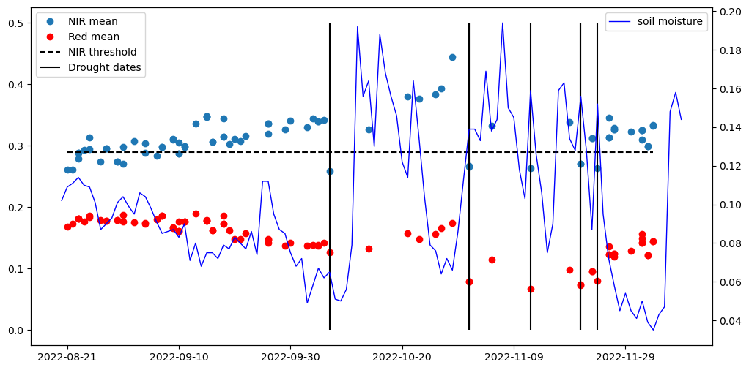

Figure 21. Planet data (dots) and soil moisture (blue line)

## 4.2 Chlorophyll Concentration (Cab)

The ARC algorithm provides temporal estimates of a full suite of biophysical variables, including leaf chlorophyll concentration. The results of this for the test sites is shown in Figure 22 and Figure 23 for MSI and Planet respectively. The results are similar for both years, with slightly stronger relationships shown in the Planet results. These data are rather difficult to assess as a scatterplot, as the dynamic range is quite small.

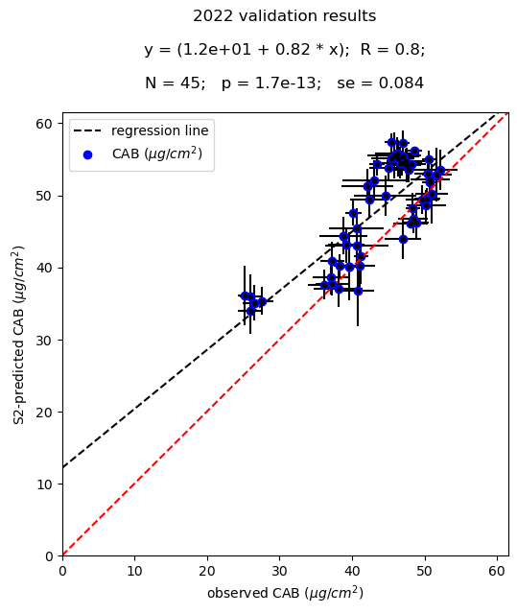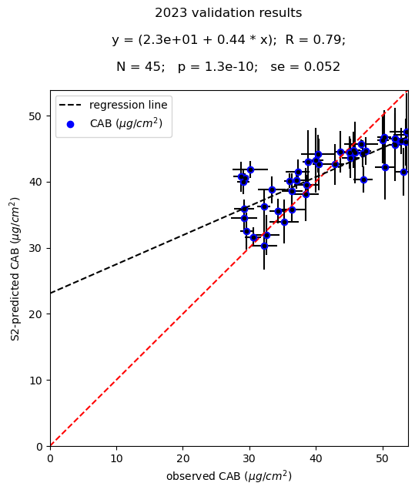

Figure 22. Cab validation using Sentinel-2 MSI for 2022 and 2023 seasons

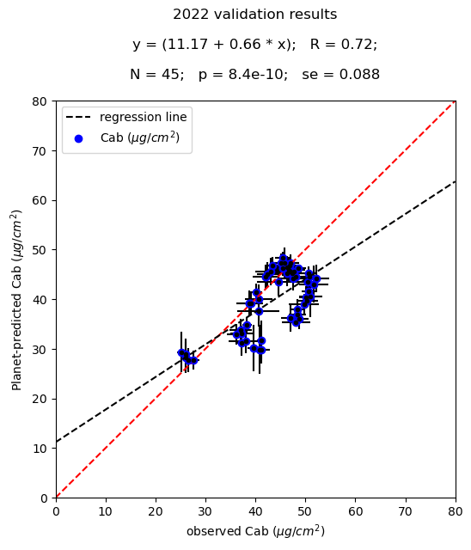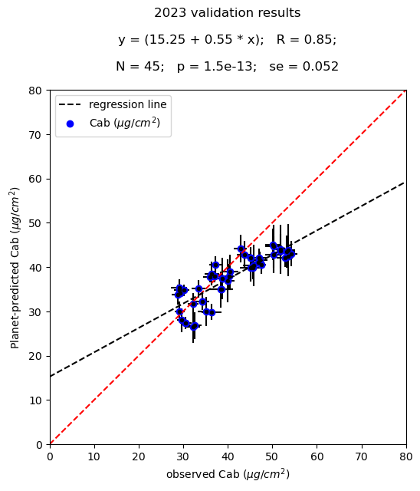

Figure 23. Cab validation using Planet data for 2022 and 2023 seasons

Figure 24. Time series of measured (red) and estimated (black) LAI from Sentinel-2 MSI (left) and Planet (right) for 2022

An examination of the time series (measured and modelled) in Figure 25 and Figure 26 shows that for 2022, the MSI data perform better early in the season, but the Planet data better in the latter part. The dataset for 2023 shows a surprisingly good tracking of the Cab levels for the first part of the season for both, but a slightly poorer performance after. It is remarkable that the estimated Cab patters broadly follow those measured for both years (and both datasets): they show similar characteristics, such as the broader distribution in the 2022 data than in 2023.

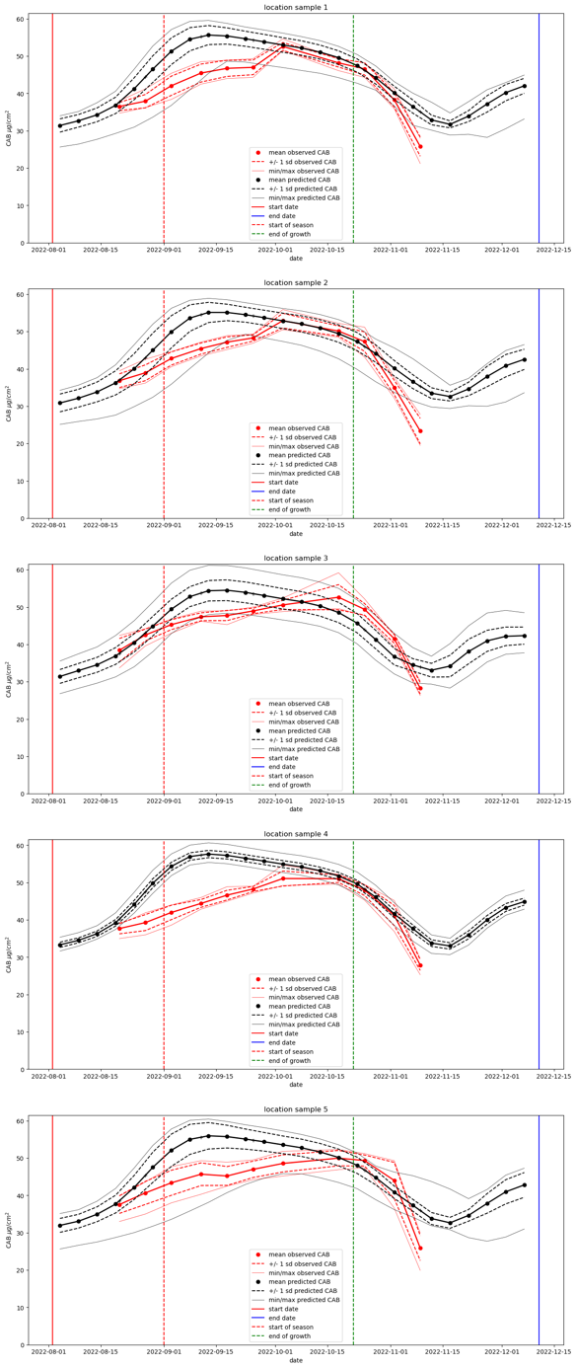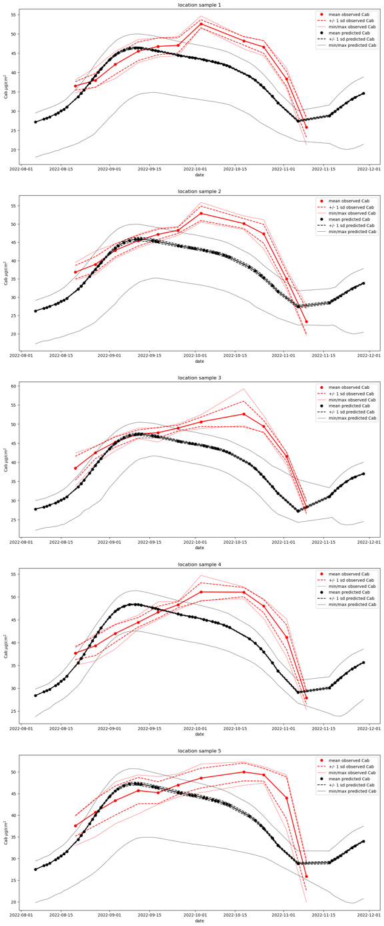

Figure 25. Time series of measured (red) and estimated (black) Cab from Sentinel-2 MSI (left) and Planet (right) for 2022

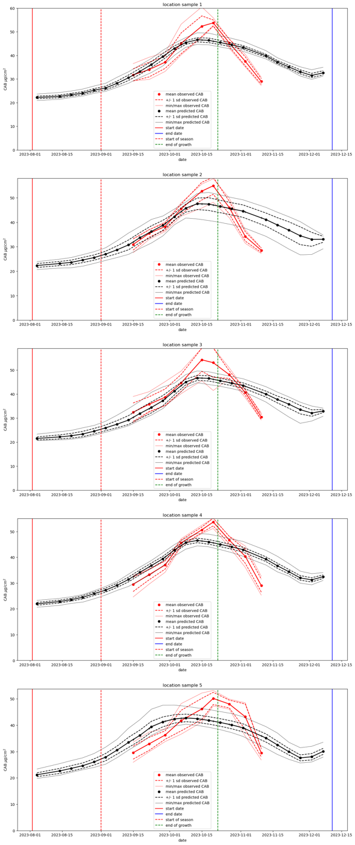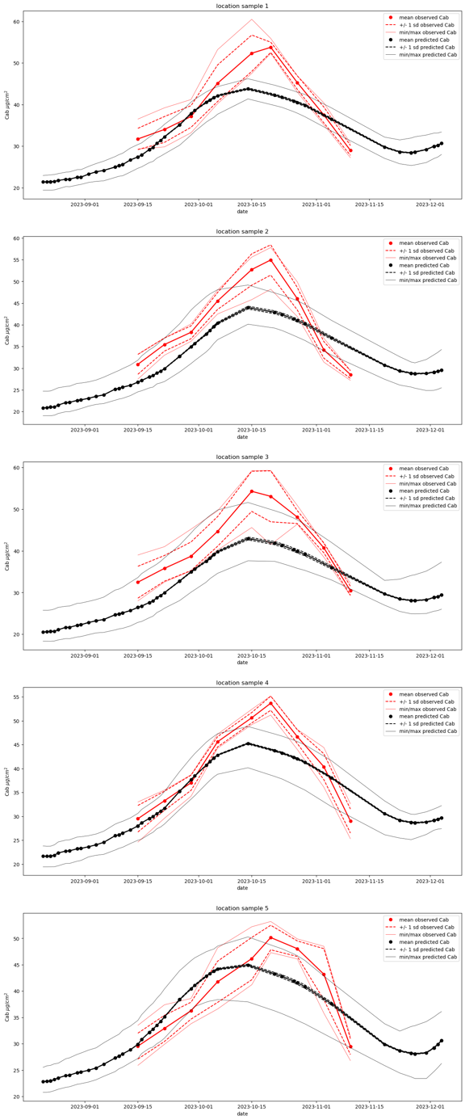

Figure 26. Time series of measured (red) and estimated (black) Cab from Sentinel-2 MSI (left) and Planet (right) for 2023

## 4.3 Results in context

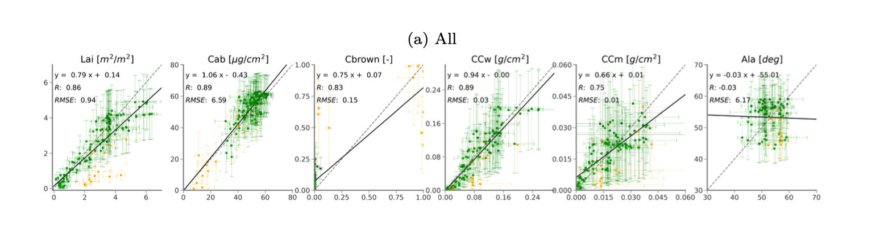

Figure 27. Figure 26. Validation results from the Yin et al. paper

Figure 27 shows the validation results presented in. Yin et al. (2024). We notice that a much wider range of biophysical parameters have been examined, but we only have measurements for LAI and Cab here. Looking at those, we see R values of 0.86 and 0.89 respectively for LAI and Cab (using MSI data), and regression equations of y = 0.14 + 0.79 x and y = -0.43+1.06 x. The R values from these results are very similar, and for the Planet data at least, slopes and intercepts of regression lines are broadly in line for both years. It would be of value to analyse these results more directly alongside other validation datasets such as those shown in Yin et al. (2024)

# 5. Other matters

## 5.1 Finance

There was a delay in setting up the transfer process between UCL and Wits that has complicated the financial process. A customer number was finally created for the Geography Department at UCL, but invoices for fieldwork and other were greatly delayed as a result.

## 5.2 Training and workshops

Elhadi Adam attended the EO AFRICA F2F Training: Cloud Computing and Algorithms for EO Analyses in Kigali, 16 to 22 October 2023, and reported back to the group on what was learned.

## 5.3 Financial expenditure

Partly because of the delay in the financial transfer process, not all of the money has been spent from the Wits end. Further, since the UCL partner was unable to attend the delayed field trails in South Africa, the UK travel money has not been fully spent. Funds for training for the African PI were deployed in October, to attend the EO AFRICA F2F Training: Cloud Computing and Algorithms workshop. Unfortunately, we do not have a final financial statement, but this has been requested from UCL. This will be provided as soon as possible after Easter.

# 6. Conclusions

The BIG-ACE project has been important in two main ways. First, it has introduced partners in Africa to methods and codes likely to improve agricultural monitoring and play a role in food security. Second, a further dataset has been collected and made available publicly that can be used for the validation of satellite biophysical parameter products. A particular significance of this is that it is a multi-temporal sequence, allowing the patterns of LAI and Cab development to be investigated. The codes and data from this project are all made publicly available. To run the codes on different areas, the user needs simply to develop a new notebook based on the examples provided, and supply a different vector file defining the area of interest.

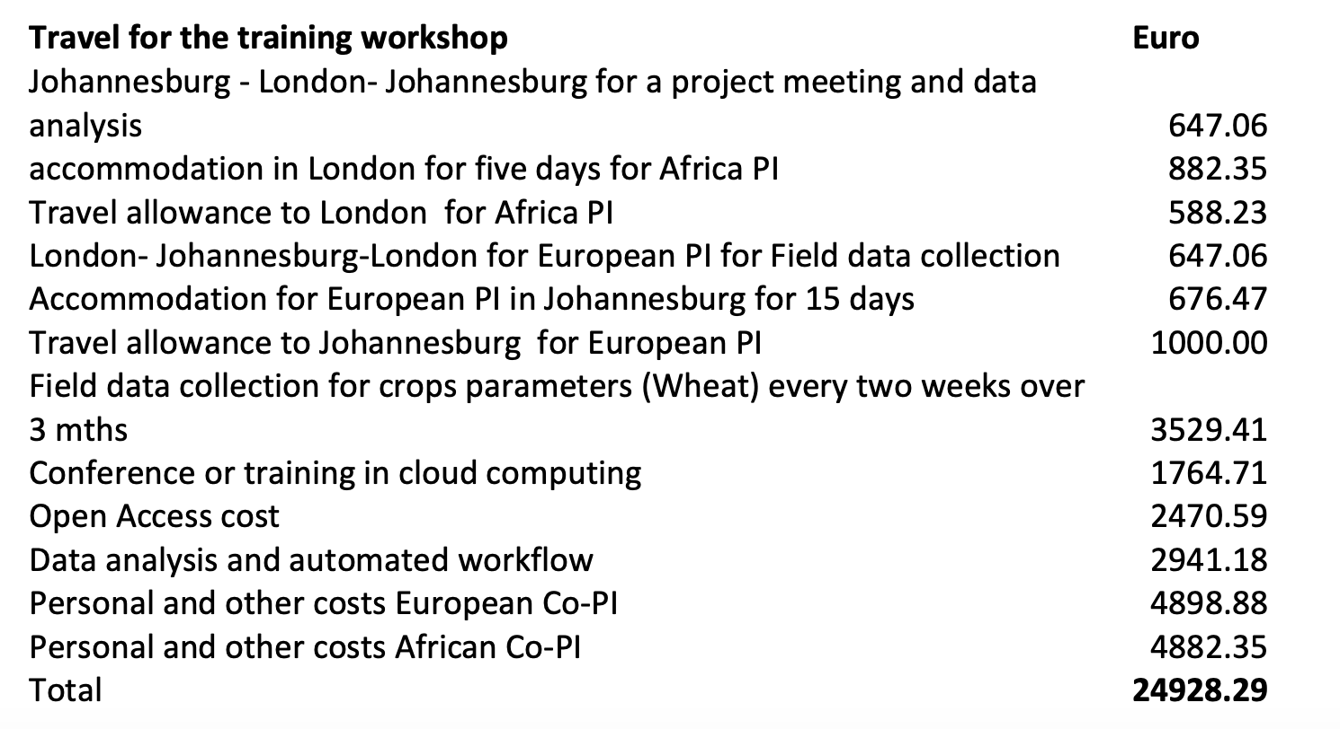

Figure 28. Proposal expenditure plan

# Appendix I. Sampling protocol for LAI and Cab

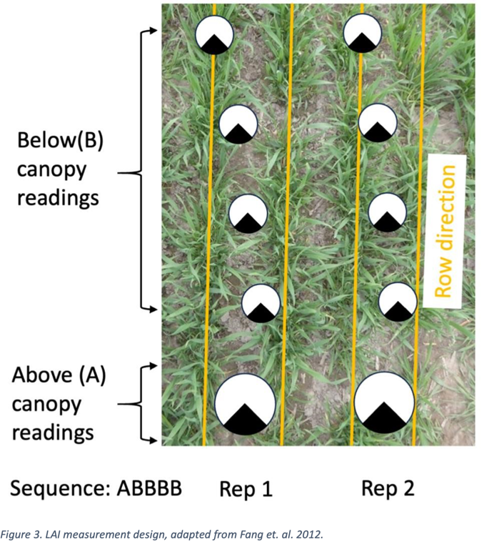

Figure 29. LAI measurement protocol. Adapted from Fang et al. 2022

1. Select five distinct locations within each field for conducting LAI measurements. These locations should represent the variability in the density of the plant population within the field and be positioned at least 10 meters away from the edges of the field to avoid edge effects.
2. Determine and mark the specific rows for measurement within each subplot. Record the GPS coordinates for each marked area for precise relocation during subsequent measurements.
3. At every marked location, perform one measurement above the plant canopy and then four measurements beneath the canopy, as depicted in Figure 3. This approach ensures comprehensive coverage of the canopy's light interception capability.
4. Maintain a consistent orientation for the view cap during all measurements at each location. Utilize a 270° view cap to prevent the sensor from detecting the operator, ensuring accurate readings.
5. Calculate the mean of all measurements taken across the sampling points to derive the LAI value for each subplot.

Key Considerations:

* Increasing the number of readings taken below the canopy enhances the spatial representation of the measurements.
* For canopies that are 1 meter in height, position the optical sensor at least 3 meters away from the canopy edge to avoid interference from adjacent areas.
* Ensure all below-canopy measurements are conducted at a uniform height of 5 cm above the soil surface and aligned in the same direction as the above-canopy measurement to guarantee consistency.

Chlorophyll Measurement Protocol:

1. Within each marked area, identify five plants for ongoing chlorophyll measurements.
2. Label the fifth and sixth leaves on each selected plant for targeted measurements.
3. On each tagged leaf, conduct measurements at three points: one-quarter, one-half, and three-quarters of the distance from the base of the leaf to its tip.
4. Execute measurements on both tagged leaves, resulting in a total of six measurements per plant, to ensure a thorough assessment.
5. Use the “Average” function to compute the mean SPAD reading for each plant, providing a representative value of its chlorophyll content.

The SPAD readings are collected from plants located in the same five sampling points selected for the LAI measurements to offer a comprehensive analysis of the chlorophyll content across different parts of the field.

1. <https://nasaharvest.org>; <http://www.cropwatch.com.cn/htm/en/index.shtml>
2. <https://github.com/MarcYin/EO-AFRICA>
3. Gómez-Dans, J. L., Lewis, P. E., Yin, F., Asare, K., Lamptey, P., Aidoo, K. K. Y., MacCarthy, D. S., Ma, H., Wu, Q., Addi, M., Aboagye-Ntow, S., Doe, C. E., Alhassan, R., Kankam-Boadu, I., Huang, J., and Li, X.: Location, biophysical and agronomic parameters for croplands in northern Ghana, Earth Syst. Sci. Data, 14, 5387–5410, https://doi.org/10.5194/essd-14-5387-2022, 2022.